Conservation of metals: Condition and treatment report

WD job no. | Date received:  28/9/2020
Object: Archaeological bronze lamp

Client: | Client accession no.

Date assessed: 15/10/2020 | Conservator:  Carola Del Mese
Supervisor/s: Eric Nordgren

Treatment start date: 15/10/2020 | Treatment completion date: 29/10/2020

Image of object as received:

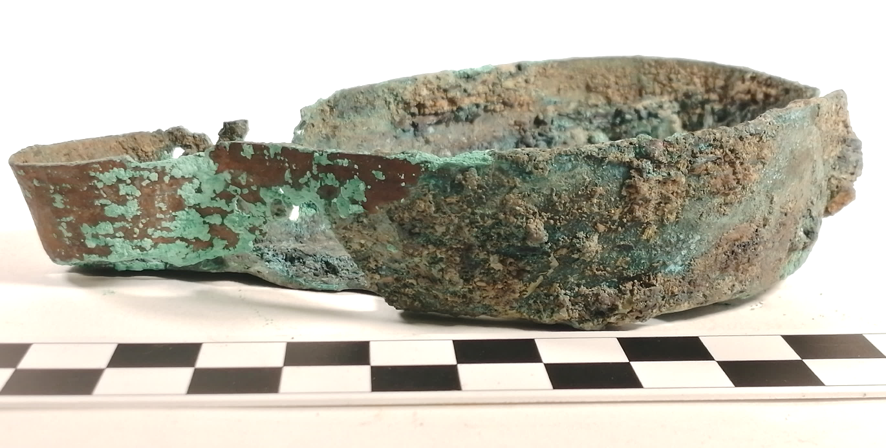

Proper left view, detached handle would have been to the right, and flame to the left.

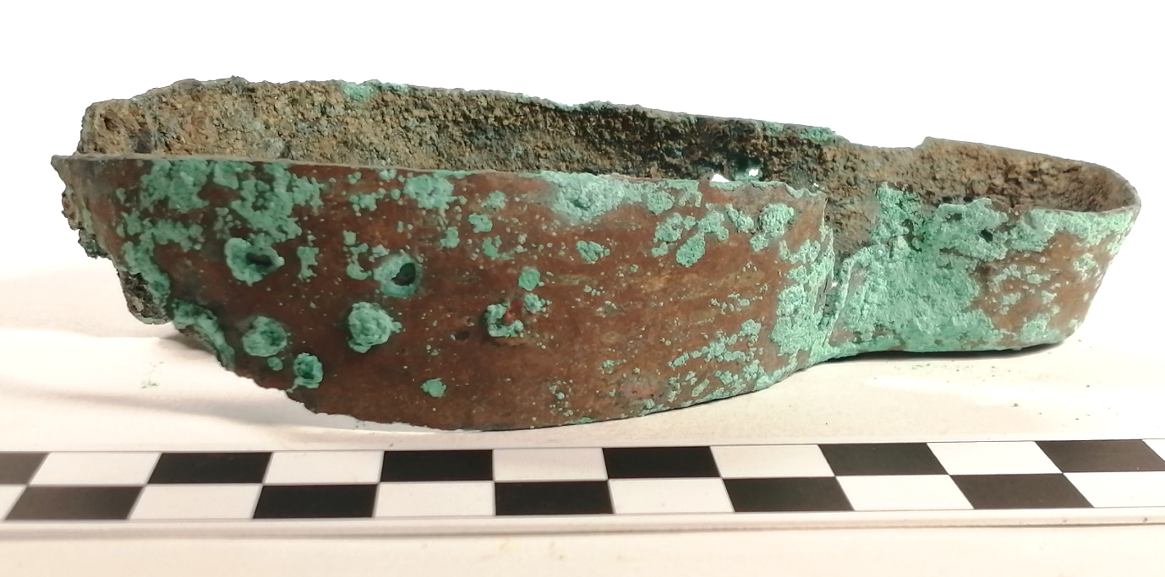

Proper right view

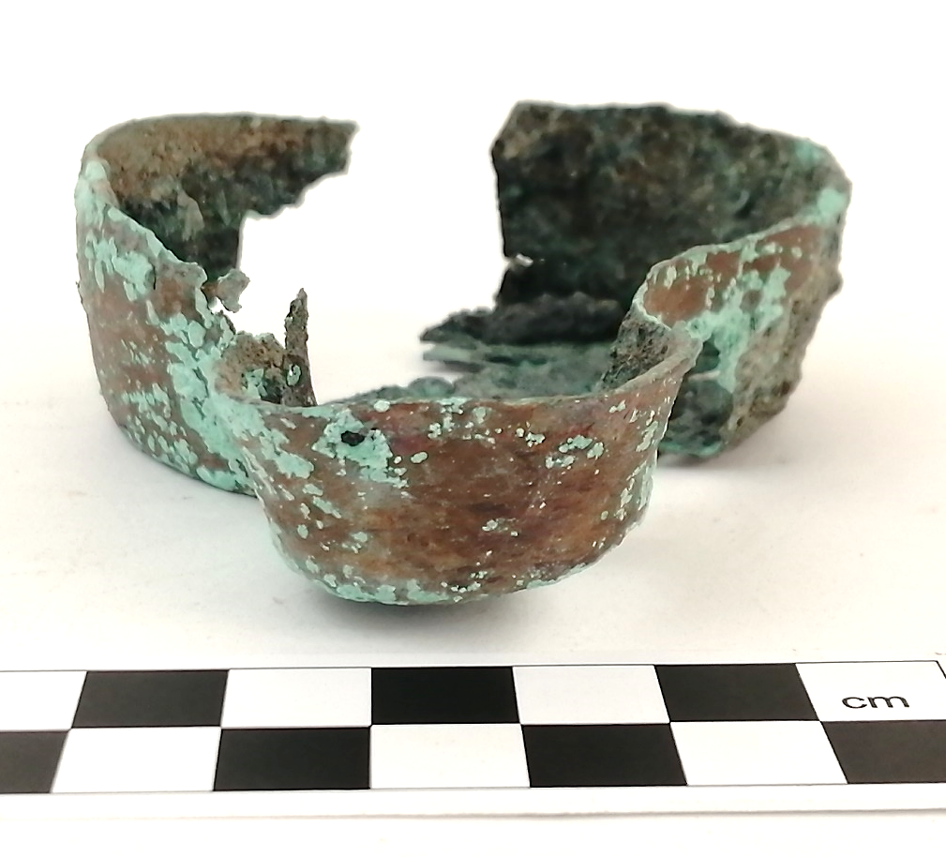

Front view

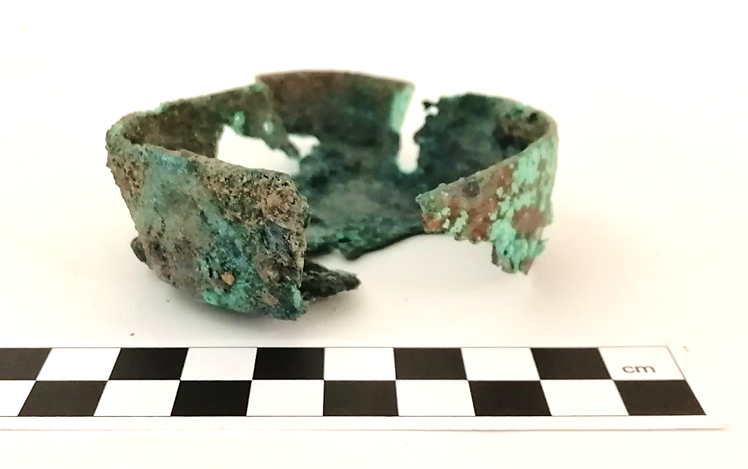

Back view, showing gap where handle would have been attached.

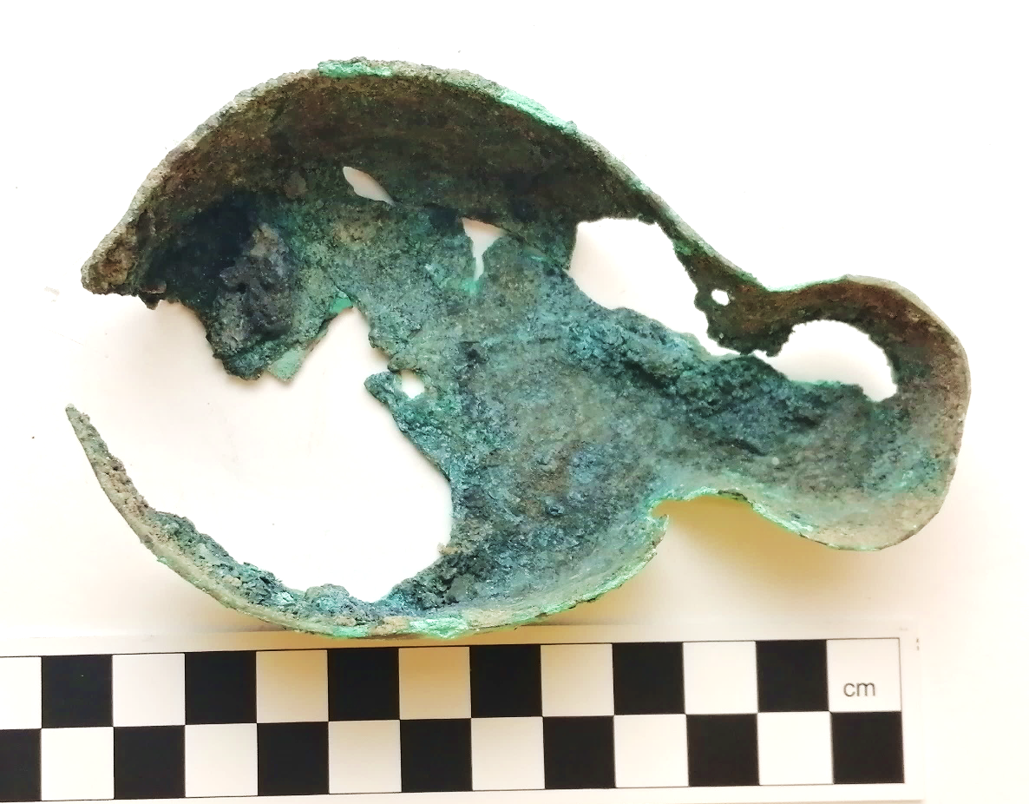

Top view

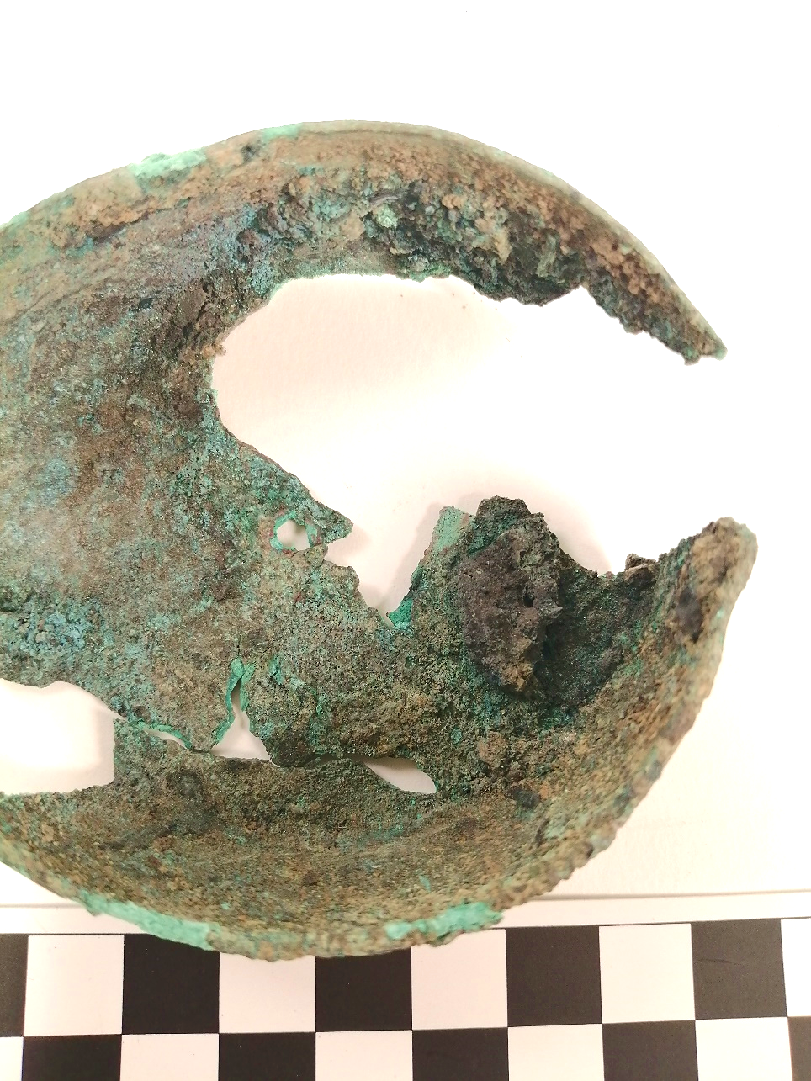

Inside detail showing the extent of damage caused by corrosion, and attached soil deposits

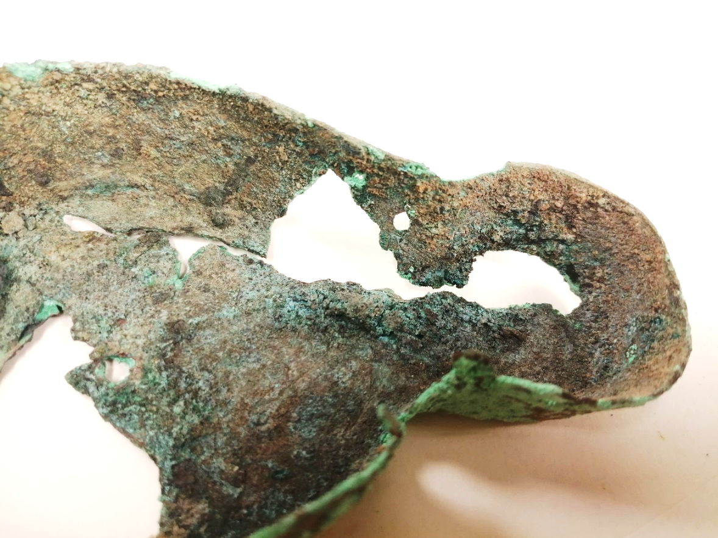

Inside detail showing large gaps with fragile edges.

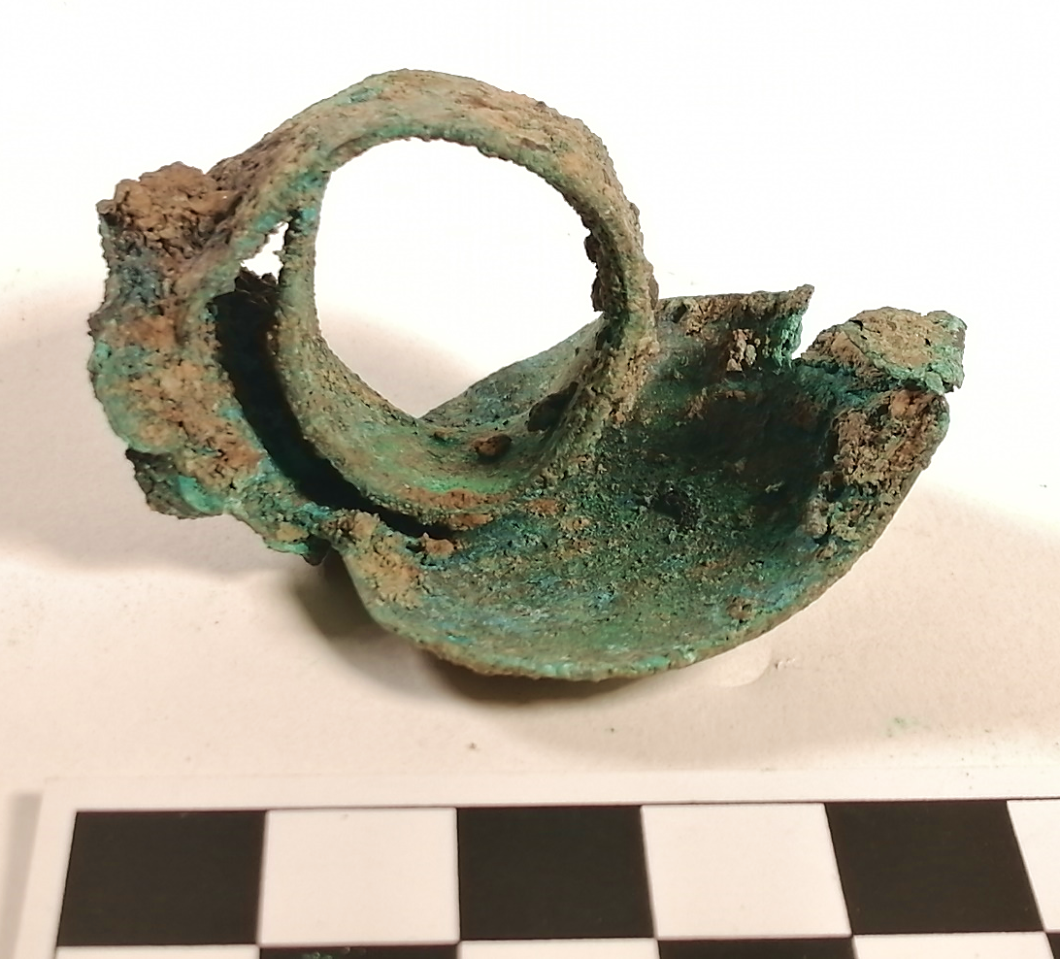

Handle shown with thumb rest underneath. (Inverted) Left side would have been attached to the lamp body.

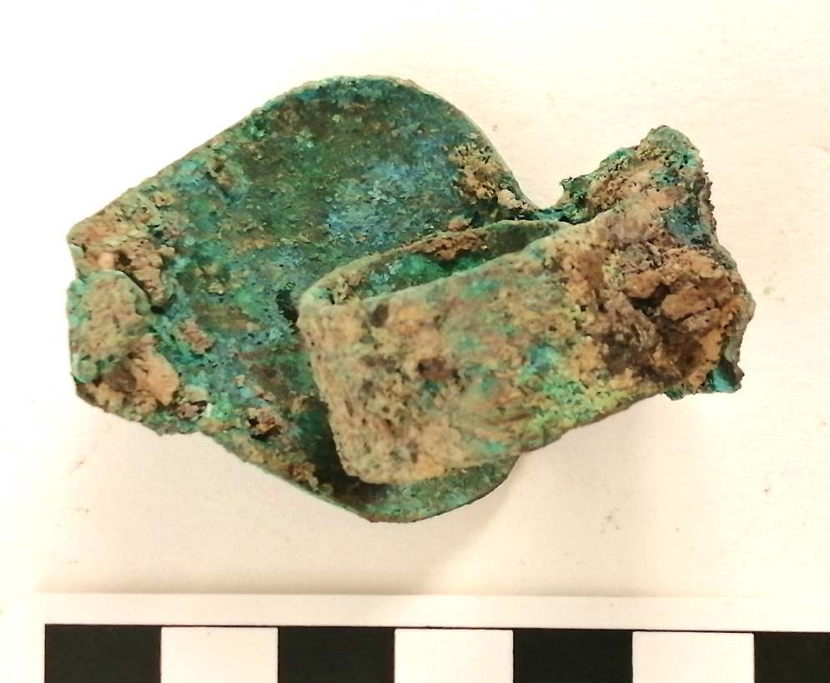

Handle view from underneath. Right side would have been attached to lamp body.

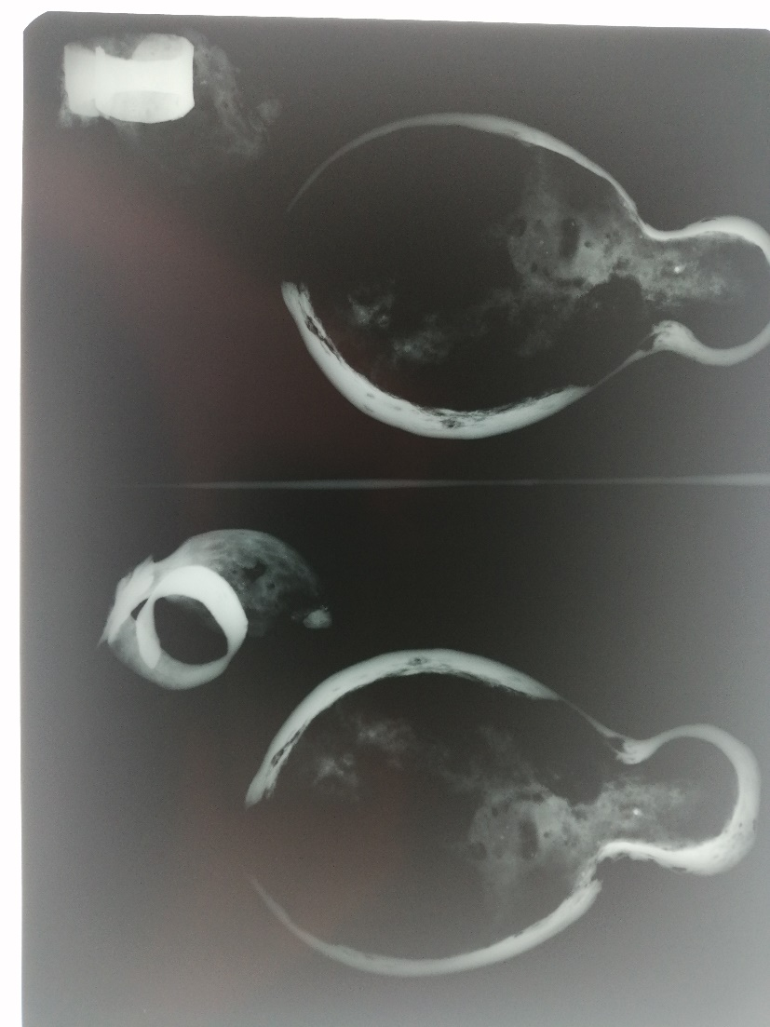
X-ray of the object from above showing the body and the handle.

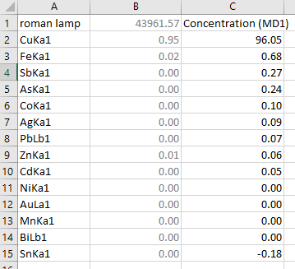

XRF analysis table of weight % concentration of elements within the object.

Dimensions/mm:
115mm total body length / oil well 75mm wide / wick well 35mm wide.
Handle: circular band for finger which forms a loop - 14mm wide, 24mm diam. Leaf shape above finger band - 40mm wide at widest point, 45mm long currently – pointed tip has become bent underneath and is attached by corrosion.

Condition in detail:
Description:
This is an archaeological object, now heavily corroded but recognisable as an oil lamp made from a copper alloy. (See table above for XRF analysis.) The main body of the lamp is a very simple open-top oil well design with a flat base, a larger circular well shape joined to a smaller circular wick well. The body of the lamp has vertical sides which angle away from the centre slightly, and it is possible to see the ancient tool marks on the outer face of the object, where the original metal is still intact. There is no decorative detail visible.
The object has been received with the original handle which has become completely detached. The handle has been made from a flat ribbon of a similar alloy, once attached to the main body of the lamp with 2 x rivets which are still in place on the handle. The ribbon curls up and over from the rivets, forming a loop which accommodates the index finger, and a curved leaf shape has been attached to the top of the loop, on which the thumb would rest.
Condition:
The corrosion product was not analysed, however the object shows clear signs of bronze disease: pale green pustules have bloomed all over the surface, and the original metal has largely corroded away leaving holes in the base and sides. The pale green pustules are only evident on the outside, while inside are darker green and green/blue areas of corrosion. The object had been in the care of West Dean College for a number of years, and following initial assessment, it appears that there had been an attempt to control the outbreak of bronze disease by storing the object in a sealed plastic box with silica gel. The object had been monitored much more recently and there had been no progression in the corrosion.
There are some remaining undamaged copper alloy areas on the sides, which are averagely 1.4mm thick, and the object is fragile due to the missing areas and cracks in the structure. Careful inspection has shown that the object is very brittle, and the exposed edges are fragile, and prone to crumbling. An X-ray photograph was taken of the object, (above) which confirmed that a large proportion of the main body is now corrosion product rather than the original metal. XRF analysis of the object has confirmed that the object is 96% Cu with some trace elements of Fe, Sb and Pb (seen as As in the data).
The inside of the object is heavily textured by corrosion and soil deposits, which may be attached to the surface by corrosion. The interior texturing is black and dark brown, and some small wooden fragments are also attached to the object.

Treatment options:
- Mechanical removal of loose soil deposits and corrosion products, taking care not to remove these excessively as this may damage the fragile structure of the object.
- Treatment of the bronze disease by immersion in BTA solution, followed by desiccation to remove remaining moisture.
- Consider if consolidation is possible or necessary once the object has been cleaned. Consolidation could be undertaken with a Paraloid B72 solution. (Details in treatment carried out below)
- It is unknown whether the object will be stored, on display, or handled, nor the type of environment in which it will be kept. In this case, a protective coating is recommended in order to help mitigate undesirable environmental factors which may accelerate further damage. The recommended protective coating is a Paraloid B44 solution. (Details in treatment carried out below)
- Some areas of infill could be undertaken, in order to strengthen the stability of the object, however a complete regeneration would not be necessary.

Treatment agreed and carried out:
- Initial dry mechanical removal of loose corrosion and soil deposits was carried out using a scalpel and bristle brush. Further gentle removal of remaining soil and corrosion was achieved with a bristle brush and IMS. Finally, in order to remove as much of the green powder corrosion from the textured surface as possible, a syringe was used to flush IMS over the object.
- 2 x small wood fragments were strongly attached to the surface by corrosion, and these were left in place. It was recognised that some larger growths of corrosion had merged with soil from the burial environment, and these could not be removed as it would endanger the stability of the object.
- An X-ray was taken which confirmed that a large amount of the object is now corrosion product rather than the original metal. XRF analysis of the object confirmed that the object is 96% Cu with some trace elements of Fe, Sb and Pb (seen as As in the data).
- The lamp was immersed in a 2% w/v BTA/IMS solution for 1 hour in order to treat the bronze disease, then thoroughly rinsed with IMS to remove residue.
- The object was then left for 3 days to check whether the bronze disease reaction would recur. There was no recurrence of the reaction.

Consolidation treatment:
- There were some cracks in the body of the lamp which compromised the structural integrity, and some edges which were unstable and prone to crumbling. After consideration, it was decided that the cracks could be consolidated to provide long term structural stability. The consolidant should not be visible or draw the eye, and it was decided that 10% solution of B72 in acetone would be used.
- Prior to consolidation, the object was desiccated in order to remove any remaining moisture, and referring to the research conducted by Thunberg et al. Desiccated microclimates for heritage materials. The lamp was placed in a 1 litre airtight plastic container with 100g of silica gel, and a humidity indicator card. It was stored for 3 days and reduced to 20% rH before removing to consolidate.
- The consolidant was applied to the areas indicated in the figures below, using a fine brush. Any excess was gently swabbed away using acetone.
Coating treatment:
- After further consideration it was decided that the object should be given a protective coating. Wax was considered not appropriate.
- Tests were carried out on patinated bronze tokens, which showed that a satisfactory effect was achieved by using 2 x coats of 8% Paraloid B44 in Frigilene reducer (Xylene and Butyl acetate) with fumed silica added as a matting agent.
Infill treatment:
- On inspection, it was decided that some of the cracks in the object could not easily be consolidated as they were in fact gaps which the consolidant was not able to fill. In this case, infills were considered for the following reasons:
- The object is fragile, and infill of certain gaps would improve structural integrity, making it more resilient in the long term. Even with careful handling, the object is very fragile, and the protective coating would help to mitigate this to some extent; however, the X-ray shows that this instability exists throughout the object, and there is a risk that stress through handling could cause further damage due to its’ brittle nature and via unseen cracks. Infilling could help in this case to reduce overall stress.
- Some sensitive and structurally beneficial infilling could be undertaken, rather than a regeneration of the whole object, which would be a restoration treatment rather than conservation.
- If the protective coating is applied before infilling, this would enable reversibility.

Infills were applied as follows:
- A mix of 20% Paraloid B48 in acetone, with glass powder balloons added to the correct consistency. Pigments were added to give a base colour similar to that of the object.
- 2 layers of thin (8 – 10g) Japanese tissue paper were laid over the holes, to the outside of the object, being less visible if the object is displayed. The Paraloid B48 (15 - 20%) was applied around the edges of the paper, which were torn not cut, so that they were less visible.
- Once the solution hardened, the paste was added to the inside of the gaps using dental tools.
- When the paste had hardened, it was textured using a pin vice to match the surrounding areas.
- Dry pigments were mixed sparingly with a matt water based medium. Windsor green, yellow ochre, burnt umber and titanium white were built up in translucent layers to match the surrounding area, on both sides of the infill.
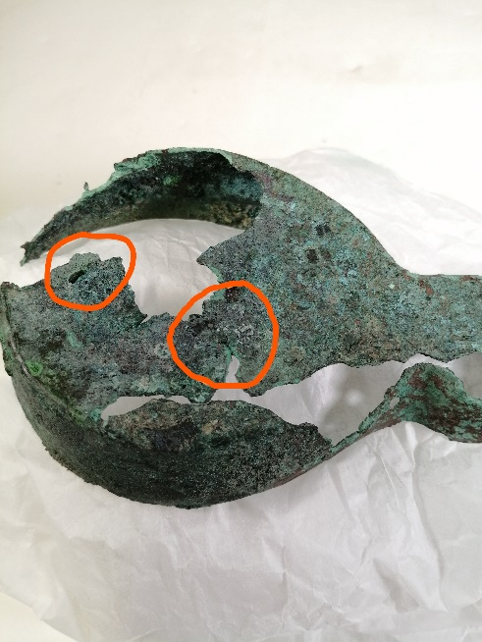
Object condition after treatment, with consolidation points ringed in orange:
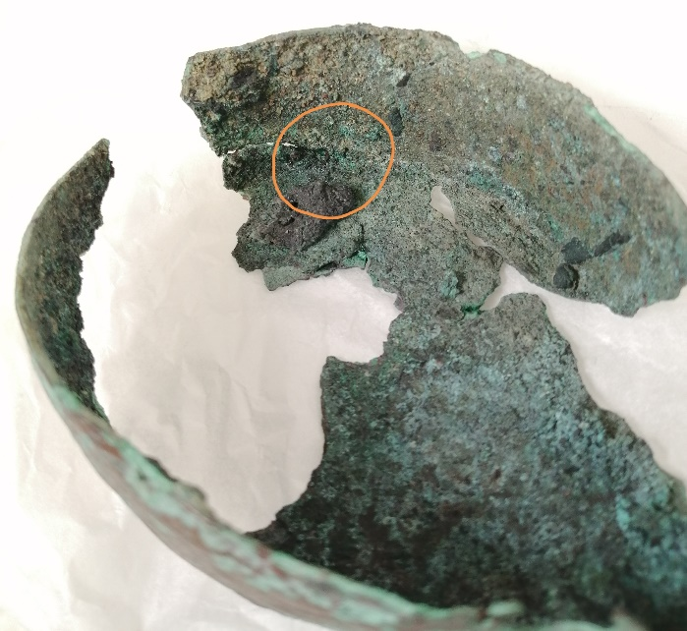

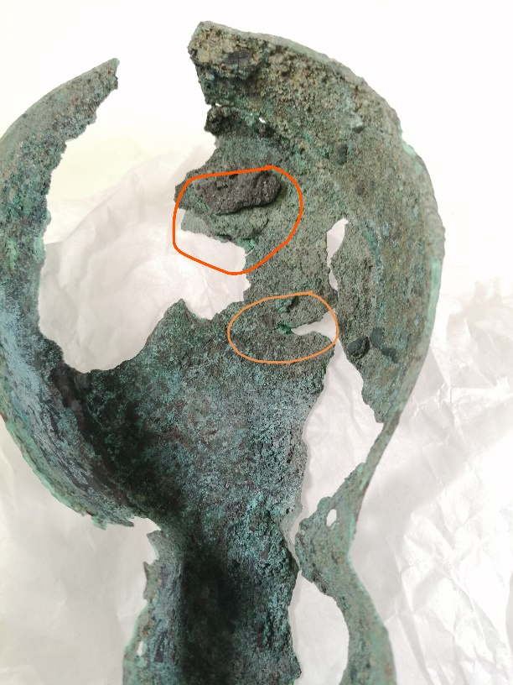
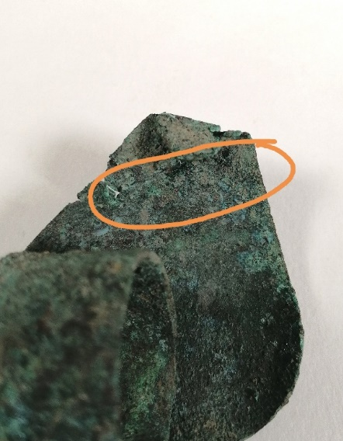

Object condition after cleaning, with proposed infill points ringed in blue:

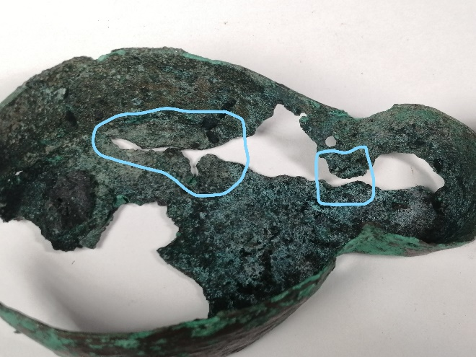
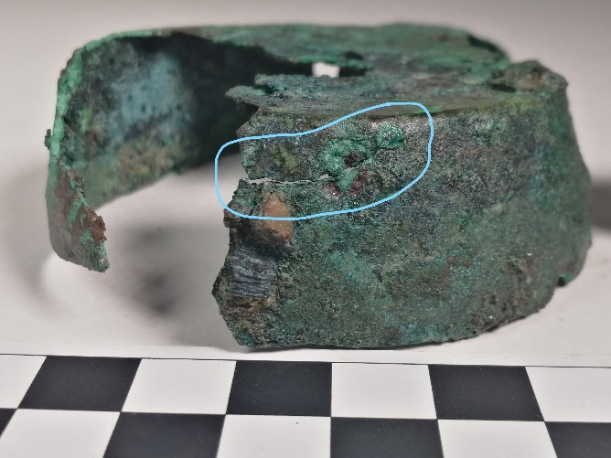

Object condition after treatment with infills ringed in blue:

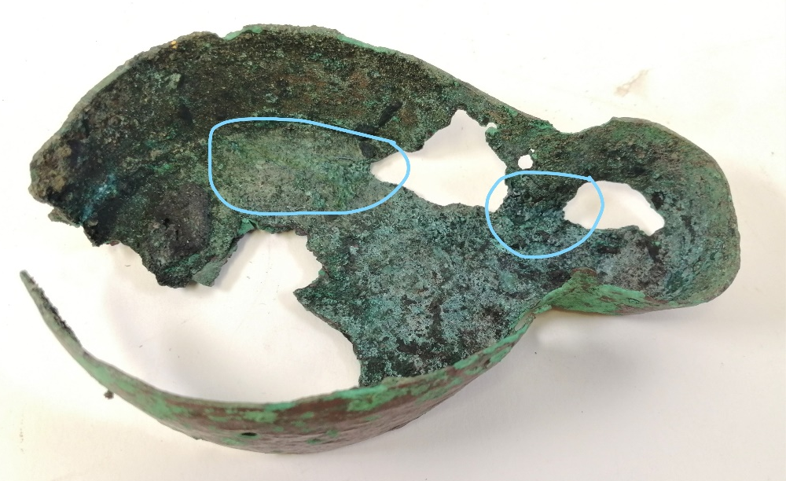

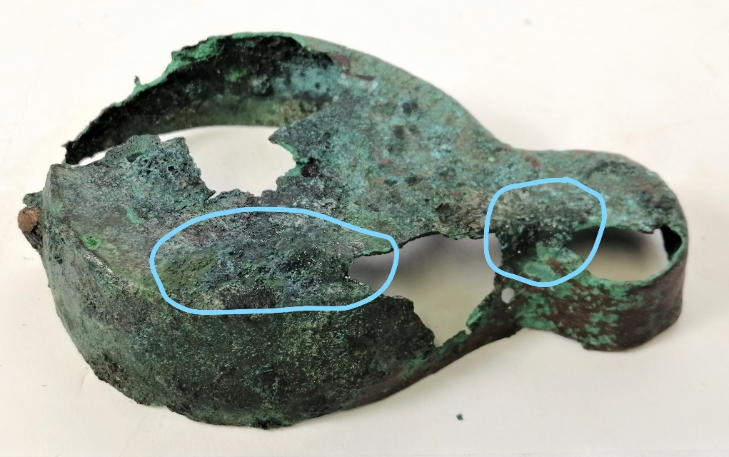

Recommended continuing care:

This is a very fragile object and should be handled with care. Handle sparingly and only when necessary. Handle using nitrile gloves. Only pick up from the base and use 2 hands. Keep in dry storage at a stable temp below 30⁰C and at an rH below 50%. Store in the box provided or a similar airtight box and replace silica gel yearly. Do not clean with water or detergent, only dust off with a dry soft brush. If on display keep out of easy reach and prevent dust build-up. Keep to the environment temperature and rH detailed above. Keep out of humidity and direct sunlight, and support adequately. Do not place anything inside the object.
Inspect the object regularly, and if bright green spots begin to appear, consult with a conservator for treatment.

Materials used and suppliers:

- Benzotriazole – Sigma Aldrich
- IMS - Unknown
- Acetone - Sigma Aldrich
- Paraloid B72 and B48 – Kremer pigments
- Frigilene reducer - Walsh
- Japanese tissue paper (8 – 10g) - Unknown
- Fine glass micro balloons - Gurit
- Dry artist pigments: Windsor green, yellow ochre, burnt umber and titanium white - Windsor and Newton
- Matt water based medium - Windsor and Newton

