Conservation of Metals
Condition and treatment report

WD job no. CCM1FM/0309 | Date received: 26/10/21
Object: iron shield boss
Client: Worthing Museum | Client accession no. 1988/459

Date assessed:1/11/21 | Conservator: Carola Del Mese
Supervisor/s: Eric Nordgren, Kate Jennings
Treatment start date: 27/10/2021 | Treatment completion date: 1/5/22

Image of object as received:

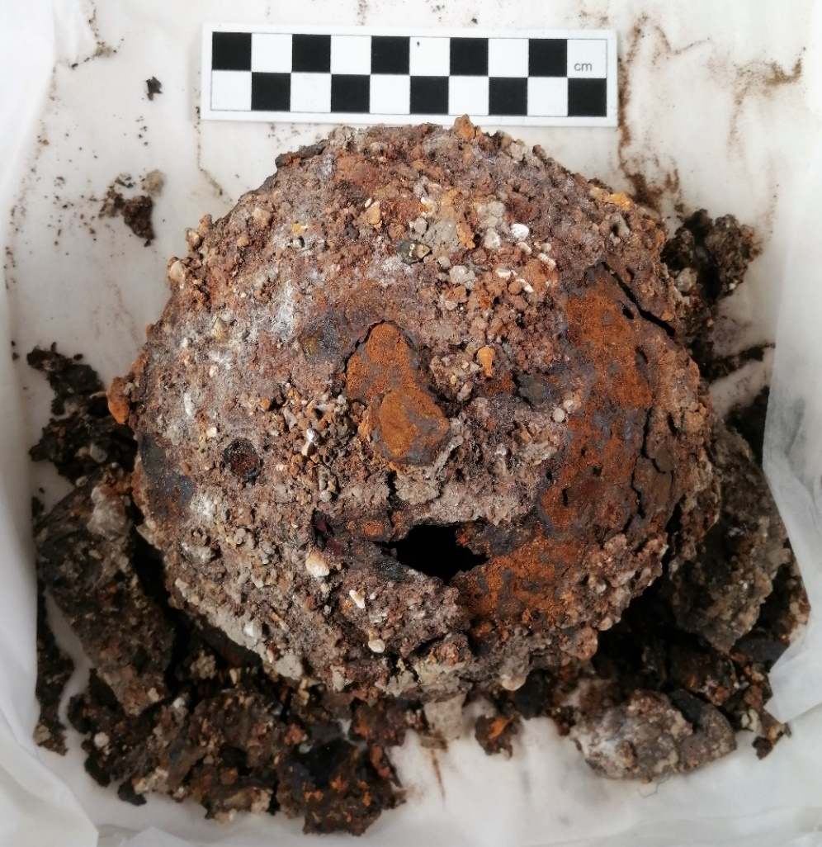
Fig. 1: Top view

Views around the exterior:

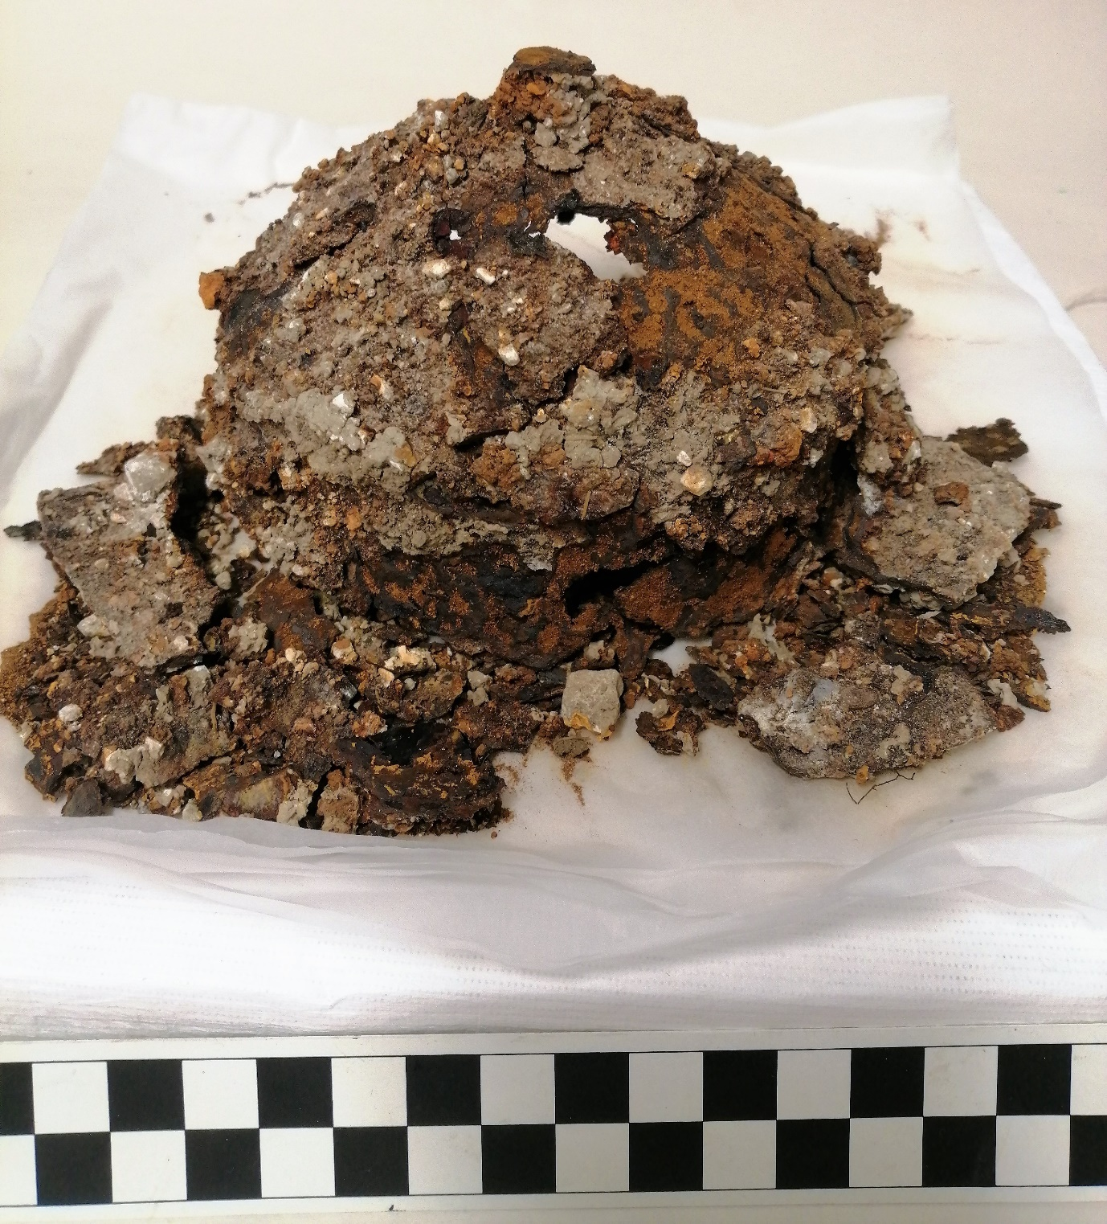

Fig. 2: Showing fragments of the flange and fragility of the structure.

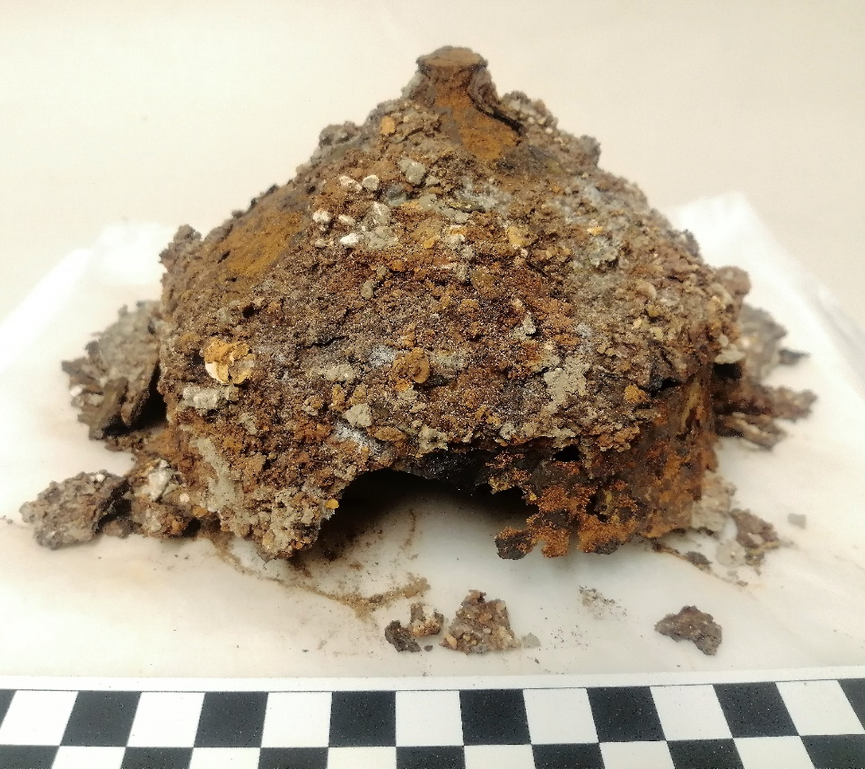
Fig. 3: Showing some remaining underlying metal around the sides

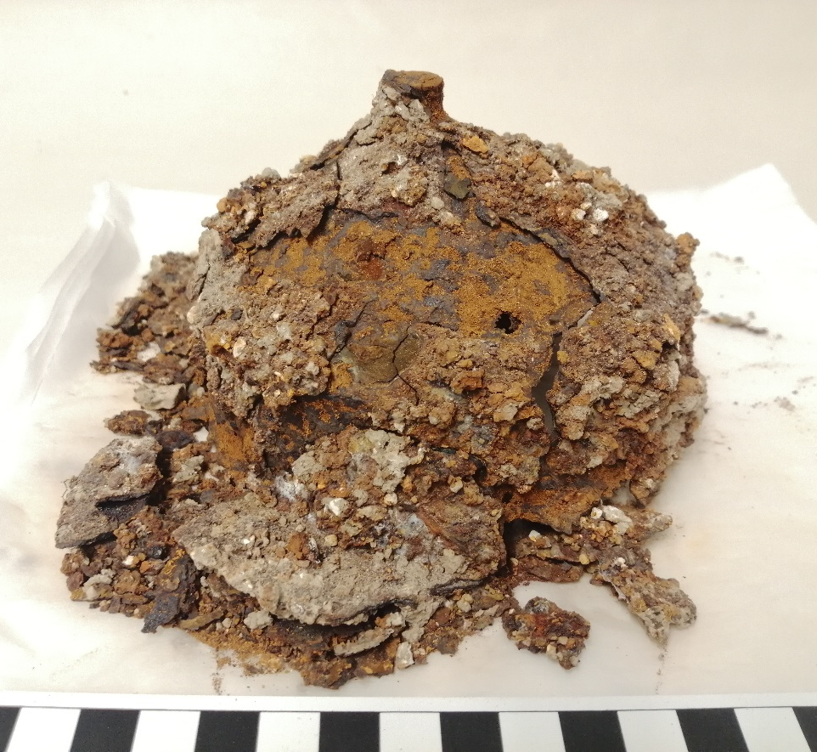
Fig. 4: Showing underlying metal on the cone, and disintegrated fragments

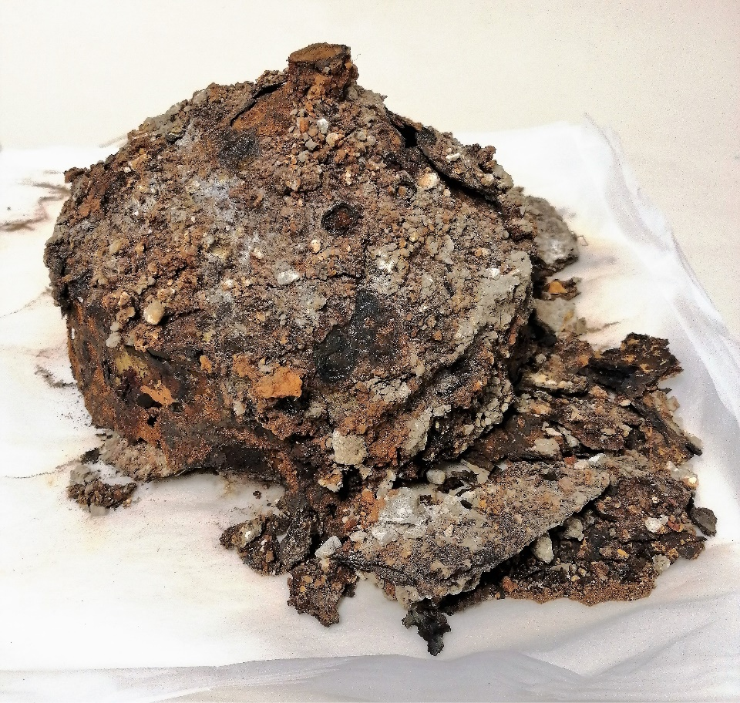
Fig. 5: Additional aspect of the sides

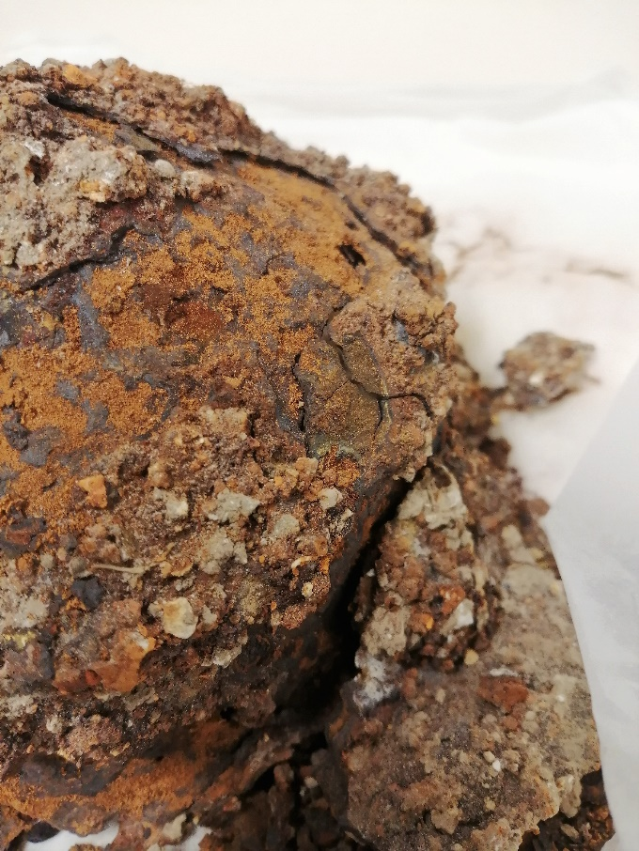
Fig. 6: Detail showing close-up of cracks and loose fragments

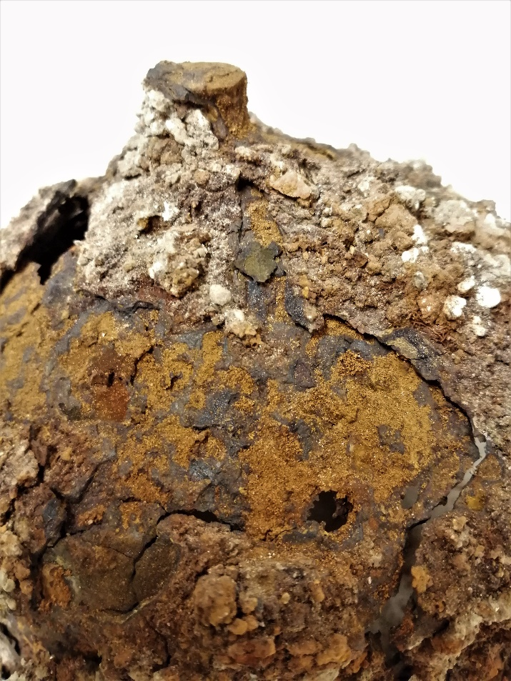
Fig. 7: Detail showing some fragments unattached and resting in place.

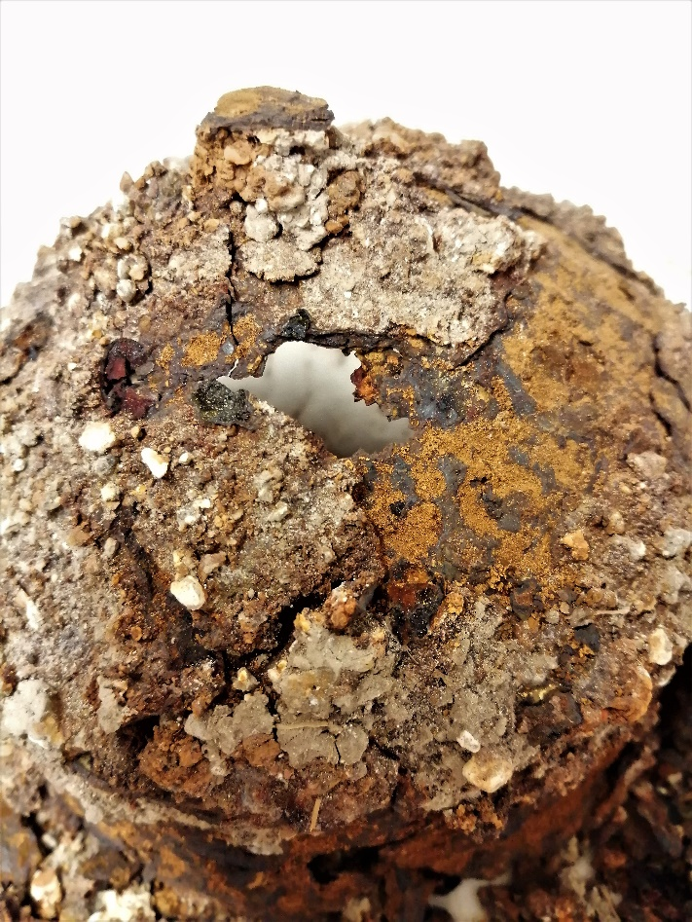
Fig. 8: Unattached fragments

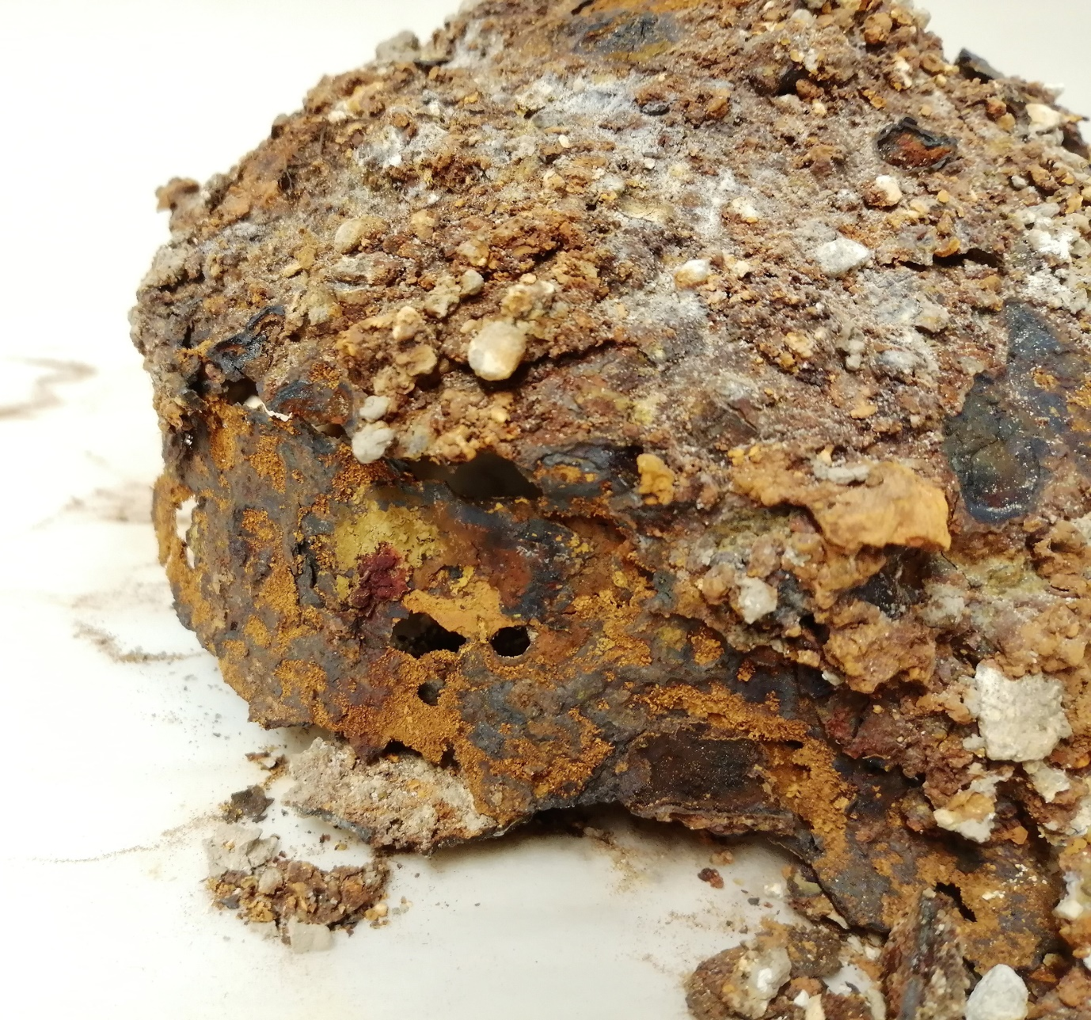
Fig. 9: Detail of underlying metallic layer

Dimensions/mm: 120mm diam, 80mm total height, 15mm diam central rivet, rivet extends 10mm, sides approx. 40mm h

Object Description:
Object is an early Saxon, iron shield boss from Highdown Hill, NW of Worthing in Sussex. Following tree planting 1892, a burial ground was discovered, containing 150 young male ‘warriors’ approx. 6ft tall. The graves included a number of fine objects including weaponry, glassware and jewellery. Two papers on the excavations were published at the time by the archaeologist Charles Hercules Read, in Archaeologia, Volume 55, Issue 1, 1896 and Archaeologia, Volume 54, Issue 2, 1895. This particular shield boss was excavated in 1988 at a subsequent dig in the same place, reported in: Gardiner, M. Excavations at Highdown Hill, 1988, 1996, unpublished excavation report. Access to these papers has not been possible.

Research has shown that the shape of this boss matches the typology of early Saxon shield bosses both in the UK and in Europe, and similar examples were plain, with no decorative motifs. See:
Dickinson, Tania & Härke, Heinrich. (1992). Early Anglo-Saxon Shields: II. Typology of Metal Shield Fittings. 10.1017/S0261340900028137.

The shape of this shield boss is described in other examples as conical. It has a flat topped, round rivet central to the shallow cone, with vertical or cylindrical walls. There was originally a flange around the edge, which has crumbled, but there are 4 large fragments which show the original shape of the flange including 2 rivets, and the general shape is still visible. Many small fragments and associated soil and debris are also included with the object in a separate bag.

Similar objects :
The Memory – Netherlands art and heritage database

Condition in detail
The boss is extremely degraded, more so now than when it was first assessed in August 2021, this may be due to handling and transport from the Museum. Before August, 2021 the storage did not include silica gel, the box may not have been air tight, and it is not known how long the object was stored in this condition. It has cracked and fragmented in numerous places, leaving losses and holes, and showing that the remaining material is very thin and fragile. The outer layer consists of soil and pebbles, presumably attached to the corrosion matrix, which has delaminated from an under-layer in some areas, revealing a brown powdery residue, and under that, a dark brown layer, which is very fragile and thin. This underlying layer has been tested with a magnet and is ferromagnetic indicating that there is still some metal present, which has not corroded. It would be advantageous to take X-rays of the object to determine the extent of the metal, which may help to determine the consolidation method. The object as a whole is cracked and fragmented, and some pieces are no longer joined to the object, but are simply resting in place. There are many small fragments accompanying the object and it may be difficult to ascertain their original position. It may be possible to reconstruct the larger detached fragments to some extent, as photographs were taken in August when the object was in slightly better condition, and these could be referred to.
It is evident that if action is not taken to consolidate the object immediately, it may disintegrate following insensitive handling, and has already suffered from being transported. It should not be handled at all, until it has had some remedial treatment.
On closer inspection, there seem to be remains of threads or vegetation in some places, which are incredibly friable and should be kept to one side if possible. A cross section of a broken piece shows definite layers which have delaminated slightly and could indicate details of the manufacture.

Treatment agreed and carried out:
- Corrosion inhibitor applied to remaining metallic areas in order to arrest any further corrosion.
- Consolidation of loose exterior fragments from the dome has been undertaken.
- It has been possible to re-join some fragments of the flange together to create larger fragments, (figs 10 – 12) however as the object is so extensively degraded, and has warped over time, it has not been possible to re-attach these flange fragments to the body.
- Due to the extensively degraded nature of the object, the edges are very friable and frequently crumble if touched. For this reason it is not possible to correctly match the remaining fragments in their places.
- The fragments which can be placed both on the exterior and the flange have been attached using Paraloid B72.
- A supportive archival storage has been created, (fig 13) which also displays the largest fragments in their correct locations around the dome. The remaining disintegrated elements of the object are stored in a separate bag with a desiccant inside.
- It was decided not to attempt any removal of soil, as this now forms part of the delicate integral structure of the object and removal of any part of the object would risk further damage.
- It was decided not to consolidate the whole object i.e. by coating, as any consolidant added would be impossible to remove (due to the porosity of the material) and would prevent further research.

Images after treatment

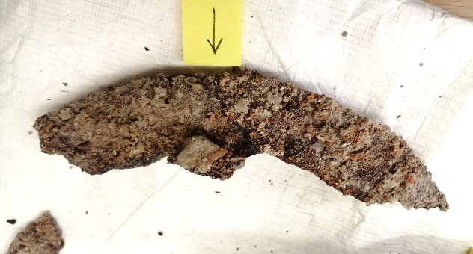

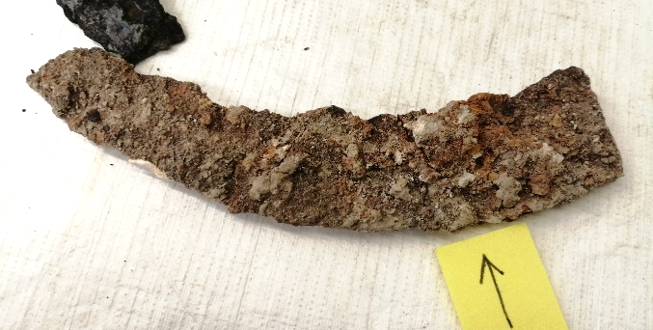

Figs 10 – 12. Details showing reconstructed fragments of flange.

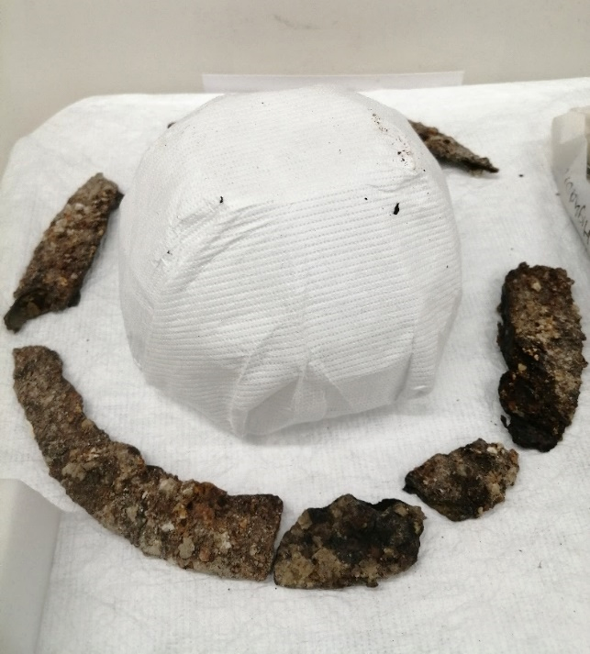

Fig 13. Internal support of archival box.

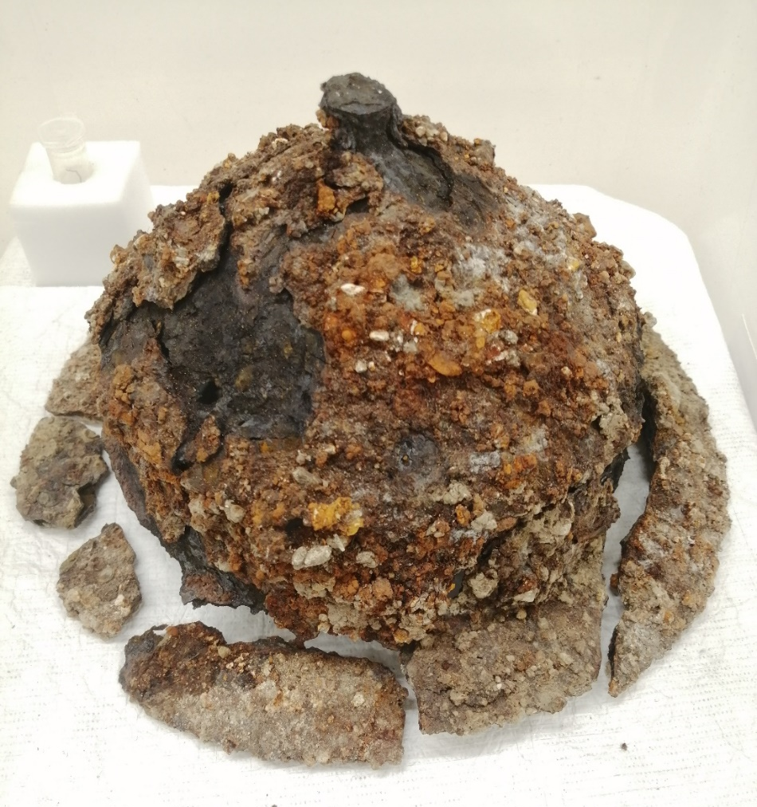
Fig 14. Object as it is stored with surrounding flange fragments pinned into place. The only re-attached fragment indicated.

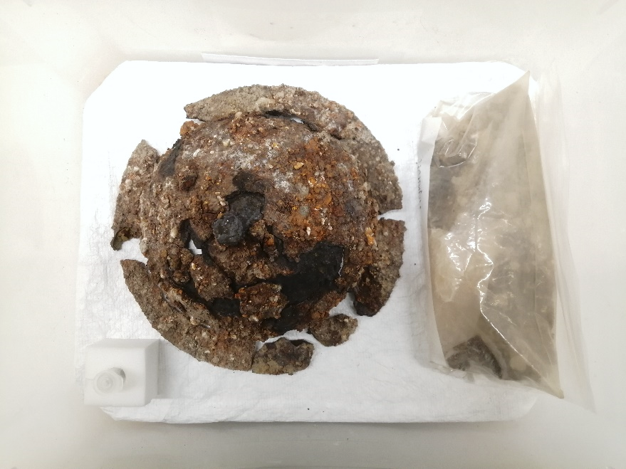

Fig 15. Object in archival storage container with sample container and bag of smaller fragments.

Recommended continuing care:
The object is extremely fragile, and in danger of disintegrating further if handled. To avoid further deterioration due to corrosion, the object must be kept in appropriate storage conditions: an airtight box, containing the appropriate amount of desiccant in perforated bags. This has been provided as part of the treatment. The ideal relative humidity for storing archaeological iron is recommended by English Heritage as follows:
to avoid corrosion - between 11% - 19%. Between 20% - 30% corrosion would be retarded and at a low level. An RH of 20% is achievable in the storage box provided. The desiccant should be checked every 6 months, and when the orange beads turn green it should be refreshed.
The object should not be handled, however if it is necessary, please wear nitrile gloves - not cotton, as the object could easily snag and cause damage. take extreme care as some sections of the walls are only attached by very narrow regions of corrosion product and are liable to break if pressure is applied. Do not apply pressure to any part of the object, and do not rest on a flat surface. Instead create an internal support which will keep the walls from touching the tabletop. This can easily be done using a ball of aluminium foil.

Materials used and suppliers:
Tannic acid – Sigma Aldrich
Paraloid B72 – Preservation equipment (PEL)
Acetone

